**Thursday 6 August 2026**

**u3a Outing by Public Transport to Visit the Original Jewish London**

**Cost of this trip is £15 and lasts about 2 hours, 15 minutes and starts at 11 am. We will meet outside East Croydon Train Station, or Aldgate Underground Station –(NOT the nearby Aldgate East Station) and ends close to Bank Underground Station.**

Stroll through the true City of London (also known as the Square Mile) where the original Jewish London existed a thousand years ago.  Discover hidden gems of the older Jewish history as we come across fascinating sights and I introduce you to enthralling characters from the past (and the present too!)  And feast your eyes on the amazing contrast in buildings from medieval magnificence to spectacular modern-day marvels.

On this, The Original Jewish London tour you will:

* 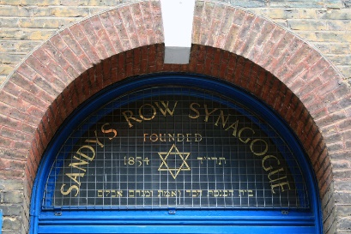come across several churches and roads within the City of London featuring the word ‘**Jewry**’ in their names and hear the enthralling reason why they were so named;
* tread the very side streets and narrow alleyways where a thousand years ago London’s Medieval Jewish community lived and endured a precarious existence before their eventual expulsion from England;  and,
* while standing on the very spot where the 1666 Great Fire of London started you will learn how the Jewish Quarter escaped the devastation despite it destroying 80% of the City
* Meet fascinating characters from the past and present including one Jewish Prime Minister of England who faced cruel antisemitism throughout his life
* the Jewish banker instrumental in Britain’s victory against Napoleon;
* the renowned 17th century non-Jewish writer and diarist shocked at his experience in a synagogue.
* 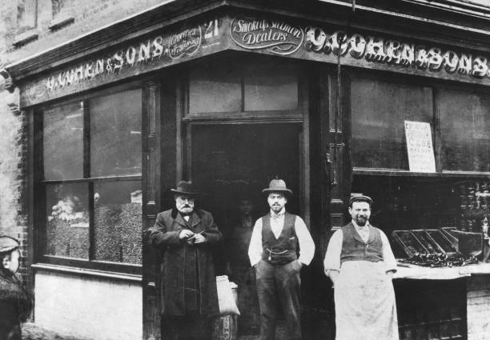meet also the billionaire entrepreneur who wanted to become the first trillionaire and not only the Prime Minister of Israel but also the President of the World;  and,
* find out why a Jewish Lord Mayor of London was physically ousted from Parliament.

As we saunter casually along main thoroughfares and through quaint alleyways in the **City of London** you will see the homes and workplaces of outstanding Jewish personalities who made their mark in this country;  also get a bird’s eye view of the tallest building in Britain;  and we’ll identify the site of a synagogue whose founder was excommunicated by the Jewish leadership, simply for building it.

Return the booking form below to: Linda Grigsby, 37 Albatross Gardens, South Croydon CR2 8QW; Mob: 07754092042 **OR** Cariss Smith, 62 Penwortham Road, South Croydon CR2 0QS; Mob: 07904 163454, either at the Monthly Meeting in the Masonic Halls, **OR** by Bank Transfer account no. 13630003, sort code 23-05-80 **(PLEASE PUT THE OUTING NAME);** **OR** with a **cheque (payable to Croydon u3a) together with stamped addressed envelope.**.

…………………………………………................................................................................................................

## BOOKING FORM – Original Jewish London on 6 August 2026

**Meet at East Croydon train station OR at Aldgate Underground Station. Times to be agreed.**

Name(s)................................................................................... Membership No(s) ............................

Address ..............................................................................................................................................

Postcode: ....................Mob No. ...................................E-mail ...........................................................

I would like .......... ticket(s). Total £.............. (cheque payable to “**Croydon u3a”) together with stamped addressed envelope** to. **OR** by Bank Transfer account no. **13630003, sort code 23-05-80** **(PLEASE PUT THE OUTING NAME);**

My contact in case of emergency is: Name.................................................Tel. No. …………………

**CROYDON u3a TRAVEL TEAM EVENT**

**General Information and Booking terms and conditions**

Please carefully read these **Booking Terms and Conditions**, as submission of a Booking Form will be taken as your acceptance of them. We also request that you carry Identity details with your name. Please also carry a card with your contact in case of emergency, Tel. number and any significant medical conditions.

**Coach Pick up and Drop off** are at Fairfield Halls Bus stop KA. See cover page of poster for times. On the day of an outing, if you have any problems joining the trip, please ring the Trip Organisers (mobile numbers on cover page of poster or on the ticket) by 7:00am. Outings are for Croydon U3A members only. In the event of low take-up, we may take members from other U3As and non-U3A members on an occasional basis.

**Booking Forms**: Booking forms for each outing are dealt with individually. When booking for multiple trips, a **separate booking form and stamped addressed envelope** are required for each one. Your booking may be jeopardised if this is not done. If you request more than one place, we must have the first name and surname and U3A number of each person.

**Payment:** Make payment online to Croydon u3a Business Account No. 13630003 Sort Code 230580 **Reference** – insert your **Surname**. Alternatively, pay by cheque. Chequesmay be dated for any time between Booking Form submission date and **two months** before the outing / event date. Please send your completed Booking Form, cheque and self-addressed envelope to the address given on the Booking Form.

**Reduced admission**: We can only offer the reductions which are advertised by the venue itself at the time we book it. We cannot deal with any special offers or discounts you may personally have.

**Refunds**: Refunds are generally non-refundable unless we are able to resell the place.

**Mobility Requirements**: Some, but not all, of our outings are suitable for members with manageable mobility restrictions. You must contact the named Travel Team Trip Organiser member on the poster cover page before booking if you wish to bring a mobility aid so that we can discuss your needs.

We will mention in our publicity and outing details any significant access or safety considerations of which we are aware. **YOU MUST BE ABLE TO GET ON AND OFF THE COACH UNAIDED.**

**Restricted mobility:** Members with restricted mobility may be accompanied by a carer on any outing, but a place needs to be booked. The carer does not have to be a U3A member but will be required to pay the full cost. Members are asked to think carefully about the physical demands of the outing and their own situation before submitting an application. We need to ensure that all participants are safe and that everyone enjoys the day. Ultimately the Travel Team reserves the right to decline applications in exceptional situations, regrettable as this may be.

**Your responsibilities**: You are asked to pay particular attention to the scheduled **Arrival & Registration, Visits** and **Registration & Departure** times and assemble at the designated meeting point. If you are late, we may have to leave without you to enable us to keep to the time-table. In such an instance, you would have to arrange your own return home, and you would not be entitled to any refund for the cost of the unused portion of the day. If this should happen, we would endeavour to contact you and/or your emergency name contact number. We ask members for their mobile phone numbers and for them to ensure they are switched on during the outing. Participants are responsible for themselves and their belongings.

**Data protection**: The details you give us on the booking form will be held by the organisers until the outing has taken place and will be used only for the purpose of the outing. When it has taken place, they will be destroyed. We keep a record of your mobile numbers to save you giving us those details on every outing. Participants are responsible for themselves and their belongings.

**General**: We try to schedule comfort stops at a convenient time and place, but it is not always easy to do this for a large coach. Apart from the initial outbound departure time, most other times are approximate. We cannot predict traffic hold-ups or bad weather, both of which may affect our arrival and final departure times.