Let’s Dance
With
Croydon u3a Ballroom Dancing Team

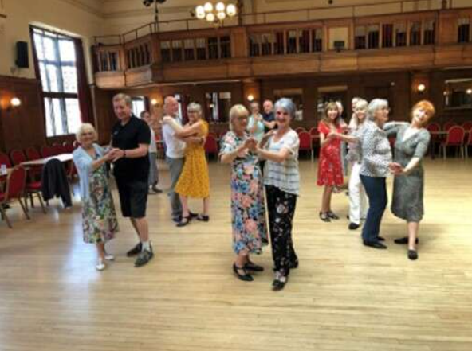

Whether you are a seasoned dancer or would like to give it a try join our Ballroom Dancing Team, led by our semi-professional coaches Thomas and Harley
You do need to come with a partner
Remember: A B C D (Any Body Can Dance)
Classes are every 1st and 4th Tuesday of the Month
At
Shirley Methodist Church, Eldon, CR0 8SD
From 11 am to 12 noon
Cost: £5 per person

Contact: Karen Hook 07799 776684/email: karen_hook@hotmail.com
Margaret Clifford 07960 982719

